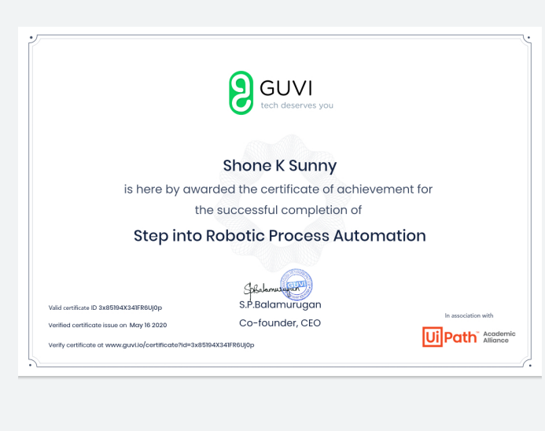

Online course completion certificate on "Step into Robotic Process Automation" during lockdown period